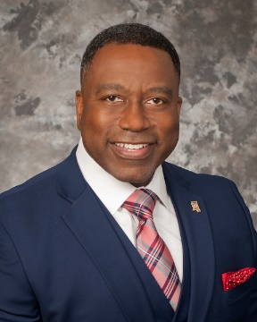

Colonel Steven Maxwell, Director, Mississippi Bureau of Narcotics
Colonel Steven Maxwell serves as the Director of the Mississippi Bureau of Narcotics. He has over 25 years of law enforcement public service as an Agent of the Mississippi Bureau of Narcotics. His leadership and management roles with the Mississippi Bureau of Narcotics include Group Supervisor of Special Operations, Captain of Special Operations, Captain of the Hattiesburg District, Captain of the Jackson Enforcement Team, Major of the Central Region, Major of the Southern Region, Lieutenant Colonel of Enforcement, Deputy Director, and most recently, Interim Director of MBN prior to his appointment as Director.

Colonel Maxwell has received numerous accolades, including the MBN Claude Stuckey Award, which was presented for a sustained and superior record of service. Colonel Maxwell was also the recipient of the MBN Director’s Award, presented for outstanding performance and contributions in furtherance of the Agency’s mission. He holds an Associate’s Degree from Mississippi Gulf Coast Community College, Bachelor’s Degree in Corrections from Langston University, Master’s Degree in Public Administration from the University of Southern Mississippi and post graduate studies in Criminal Justice. Colonel Maxwell is a graduate of the FBI 252nd National Academy Class, and served as an adjunct faculty member of William Carey University from 2013-2018.

